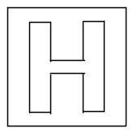

RAFFLES INSTITUTION
PRELIMINARY EXAMINATION 2010

Higher 2

CHEMISTRY 9647/01, 9746/01

Paper 1 Multiple Choice 27 September 2010

Additional Materials: OMR Answer Sheet 1 hour
Data Booklet

READ THESE INSTRUCTIONS FIRST

Do not open this question booklet until you are told to do so.

Write in soft pencil.
Do not use staples, paper clips, highlighters, glue or correction fluid.
Write your name, class and index number in the spaces provided on the Answer Sheet.

There are forty questions on this paper. Answer all questions. For each question there are four possible answers A, B, C and D.
Choose the one you consider correct and record your choice in soft pencil on the separate Answer Sheet.

Read the instructions on the Answer Sheet very carefully.

Each correct answer will score one mark. A mark will not be deducted for a wrong answer.
Any rough working should be done in this booklet.

This document consists of 17 printed pages.

Section A

For each question there are four possible answers, A, B, C, and D. Choose the one you consider to be correct.

1 Which of the following stated particles contain an equal number of particles as 12 g of ¹²C?
A aqueous chloride ions in a solution containing 0.25 mol of the complex, [Pt(NH₃)₄Cl₂]Cl₂
B hydroxide ions in 2 dm³ of 0.25 mol dm^{–3} aqueous calcium hydroxide
C oxygen atoms in 100 g of allactite, Mn₇(AsO₄)₂(OH)₈, of molar mass 798 g mol^{–1}
D oxygen atoms in 22.4 dm³ of carbon dioxide gas at s.t.p.

2 Which of the following statements is correct?

A The first ionisation energy of rubidium is higher than the first ionisation energy of calcium.
B The first ionisation energy increases from sodium to phosphorus as the number of protons increases but number of inner quantum shells remains the same.
C The second ionisation energy of chromium is lower than the second ionisation energy of manganese as manganese has one more proton than chromium.
D The second ionisation energy of any element is always higher than its first ionisation energy as more energy is required to remove an electron from an increasingly more positive species.

3 The boiling points (b.p.) of ammonia, carbon dioxide and hydrogen chloride are given below.

gas | formula | b.p. / ºC
ammonia | NH₃ | –33
carbon dioxide | CO₂ | –78
hydrogen chloride | HCl | –85

Which of the following statements is correct?

A NH₃ has a higher b.p. than HCl because the hydrogen bonding in NH₃ is stronger than the permanent dipole–permanent dipole interactions in HCl.

B CO₂ has a higher b.p. than HCl because the permanent dipole–permanent dipole interactions in CO₂ are stronger than the permanent dipole–permanent dipole interactions in HCl.

C The strength of the instantaneous dipole–induced dipole interactions increases in the order HCl < CO₂ < NH₃.

D The strength of the permanent dipole–permanent dipole interactions increases in the order HCl < CO₂ < NH₃.

4 At 298 K, two bulbs are connected by a stopcock. The 2 dm³ bulb is filled with oxygen at a pressure of 200 kPa and the 8 dm³ bulb is filled with nitrogen at 400 kPa. The stopcock is then opened to allow the gases to mix at 348 K.

The final total pressure, in kPa, of the system at 348 K is

A 420 B 400 C 360 D 310

5 A gaseous dimer, J₂, dissociates into its gaseous monomer, J, at 400 K and 1 atm pressure. Dissociation is complete at 450 K.

Which of the following graphs shows the variation of volume with temperature when one mole of J₂ is heated from 350 K to 500 K at a constant pressure of 1 atm? Assume that the gases behave ideally. (R = 0.082 dm³ atm K⁻¹)
350 400 450 500 T/ K
Vol/ dm³

800R

400R
350 400 450 500 T/ K
Vol/ dm³

800R

400R

A C

350 400 450 500 T/ K
Vol/ dm³

800R

400R
350 400 450 500 T/ K
Vol/ dm³

800R

400R
B D

6 When 25 cm³ of 1.0 mol dm^{–3} sodium hydroxide is neutralised with an equal volume of 1.0 mol dm^{–3} hydrochloric acid, the temperature of the mixture rose by 6.8 ºC.

What will be the temperature change, if x cm³ of 0.5 mol dm^{–3} sodium hydroxide is neutralised with an equal volume of 0.5 mol dm^{–3} hydrochloric acid?
(Assume heat losses to be negligible in each case.)

A 1.7 B 3.4 C 6.8 D 13.6
7 Iodide ions react with peroxodisulfate ions to form iodine and sulfate ions:

2I–(aq) + S₂O₈^{2–}(aq) → I₂(aq) + 2SO₄^{2–}(aq)

The above reaction is first order with respect to I– and S₂O₈^{2–} ions respectively. In an experiment, 5.0 mol dm^{–3} Na₂S₂O₈ was reacted with 0.025 mol dm^{–3} KI. The half-life for this reaction was found to be 6.9 s. What is the rate constant, in mol^{–1} dm³ s^{–1}, of this reaction?

A 0.01 B 0.02 C 0.1 D 0.2

8 Substances X, Y and Z react according to the following equation:

X(aq) + 2Y(aq) + Z(aq) → 2W(aq) + U(aq)

To find the rate equation for the above reaction, two sets of separate experiments were performed, in which the initial concentrations of each of the reactants X, Y and Z were varied in turn, the other two being kept constant. The results are shown below.
[X] = 1.0 mol dm⁻³
[Y] = 2.0 mol dm⁻³
time
[Z]
0.10
0.08
0.06
0.04
0.02

[X] = 1.0 mol dm⁻³
[Y] = 1.0 mol dm⁻³
[X]
0.10
0.08
0.06
0.04
0.02

[Y] = 1.0 mol dm⁻³
[Z] = 1.0 mol dm⁻³

[Y] = 2.0 mol dm⁻³
[Z] = 1.0 mol dm⁻³
time

If k is the rate constant, the rate equation is most likely to be

A rate = k[Y]² C rate = k[Y]²[Z]
B rate = k[Y][Z] D rate = k[X][Y][Z]

9 Under extreme conditions, gallium chloride, Ga₂Cl₆ can be formed via the dimerisation of GaCl_{3.}
2GaCl₃(g) Ga₂Cl₆(g)

In an experiment, a total pressure of 7.75 x 10³ Pa was measured when a 3.745 x 10^{–3} mol sample of GaCl₃ was allowed to dimerise in a 1.80 dm³ vessel at 200 ºC.

Calculate α, the fraction of GaCl₃ that dimerised at 200 ºC, assuming ideal gas behaviour.

A 0.053 B 0.105 C 0.895 D 0.947

10 The graph below shows how the fraction of a substance, X represented by one of the following compounds in the equilibrium mixture shown below varies with temperature at pressures of Y Pa and Z Pa.

4NH₃(g) + 3O₂(g) 2N₂(g) + 6H₂O(g) ΔH = −1267 kJ mol⁻¹
Fraction of X
in equilibrium mixture / %
Temperature
Y Pa
Z Pa

Identify X and the correct relative magnitudes of Y and Z.

X Pressure
A N₂ Z > Y
B O₂ Y > Z
C H₂O Y > Z
D NH₃ Z > Y

11 Which of the following conjugate acid-base pairs can be used to prepare a buffer of approximately pH 6 that has maximum buffer capacity?

A NH₄⁺ / NH₃ K_{b} of NH₃ = 1.78 x 10⁻⁵ mol dm⁻³
B H₂CO₃ / HCO₃⁻ K_{b} of HCO₃⁻ = 2.38 x 10⁻⁸ mol dm⁻³
C H₃PO₄ / H₂PO₄⁻ K_{b} of H₂PO₄⁻ = 1.33 x 10⁻¹² mol dm⁻³
D CH₃COOH / CH₃COO⁻ K_{b} of CH₃COO⁻ = 5.71 x 10⁻¹² mol dm⁻³

12 25 cm³ of 0.10 mol dm^{–3} of aqueous ammonia was added to 10 cm³ of 0.20 mol dm^{–3} hydrochloric acid. What is the pH of the resulting solution?
The pK_{b} value for aqueous ammonia is 4.75.

A 3.30 B 5.35 C 8.65 D 10.70

13 Use of the Data Booklet is relevant to this question.
Which of the following actions will allow MnO₂ to undergo a redox reaction with hydrochloric acid?

A Add Mn²⁺ to the mixture.
B Add more MnO₂ to the mixture.
C Add MnO₄– to the mixture.
D Add Cl– to the mixture.
14 Aluminium and silicon are consecutive elements in Period 3 of the Periodic Table.
Which statement concerning the compounds of aluminium and silicon is incorrect?

A Both their chlorides give strongly acidic solutions when added to water.
B Both their oxides give neutral solutions when added to water.
C Both their oxides have high melting points.
D Both their chlorides are covalent.

- The diagram shows the first ionisation energy of eight consecutive elements, P to W in the Periodic Table. Their atomic numbers lie between 3 and 20.

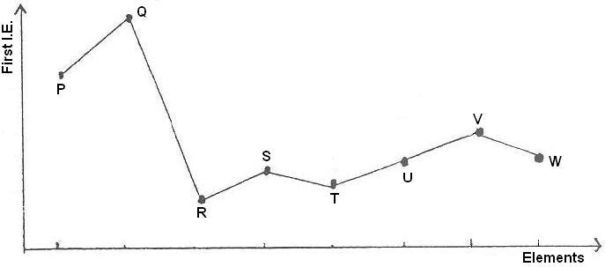

Which of the following statements is incorrect?

A P forms an acidic oxide.
B R is strongly oxidising.
C U does not dissolve in water.
D W forms a hydride of general formula H₂W.

16 Which one of the following statements concerning the thermal decompositions of anhydrous magnesium nitrate and anhydrous barium nitrate is incorrect?

A Lattice energy of magnesium nitrate is more exothermic than that of barium nitrate.
B Nitrogen dioxide is evolved at a lower temperature from magnesium nitrate than from barium nitrate.
C The oxide from the barium nitrate is formed more readily than that from magnesium nitrate.
D The volume of acidic gas evolved from the decomposition of 1 mole of barium nitrate is four times that of the neutral gas evolved from that 1 mole of magnesium nitrate.

17 Why is hydrogen iodide a stronger acid than hydrogen chloride?

A A molecule of hydrogen chloride is more polar than a molecule of hydrogen iodide.
B The enthalpy change of formation of hydrogen iodide is greater than that of hydrogen chloride.
C The covalent bond in the hydrogen iodide molecule is weaker than that in the hydrogen chloride molecule.
D The dissociation of hydrogen chloride molecules is suppressed by the stronger permanent dipole–permanent dipole interactions.

18 The table shows the possible oxidation states of four d-block elements in the Periodic Table. (The elements are represented by letters which are not their symbols.)

element | possible oxidation numbers
W | − | 2 | 3 | 4 | − | − | −
X | 1 | 2 | 3 | 4 | 5 | − | −
Y | − | − | 3 | 4 | 5 | 6 | −
Z | − | − | − | 4 | 5 | 6 | 7

Which of the following ions is likely to exist?

A WO₃⁻ B XO₄²⁻ C YO₄⁻ D ZO₄³⁻

19 Maytansine is a potent antitumour agent. How many chiral centres are present in the product of the reaction between Maytansine and Br₂ in CCl₄ in the dark?

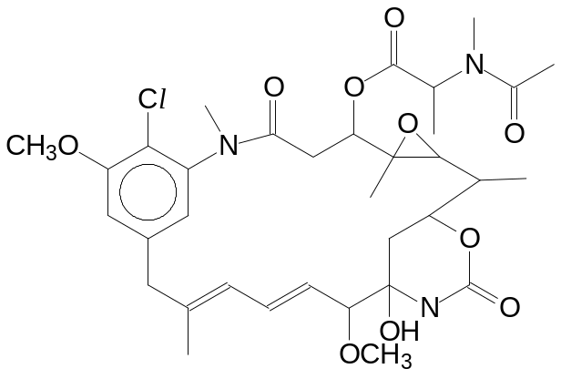
Maytansine

A 8 B 10 C 12 D 14

20 How many H atoms are in the same plane as H_{a} in the following molecule?

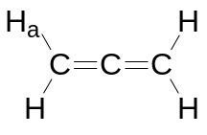

A 0 B 1 C 2 D 3

21 In which of the following pairs does reaction I take place more rapidly than reaction II?

A | 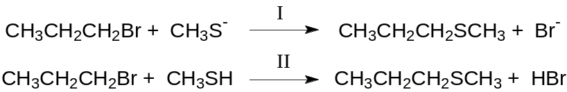
B | 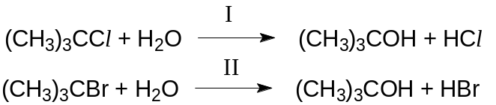
C | 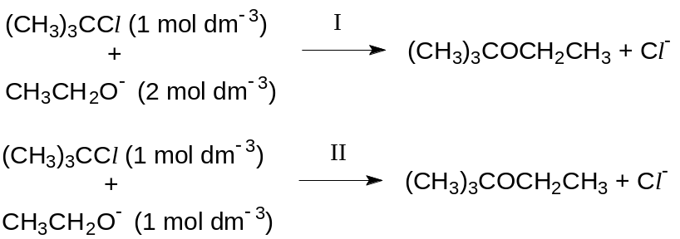
D | 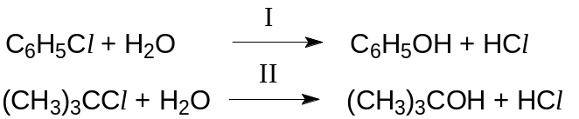

22 Arrange the following compounds in order of decreasing K_{b}.

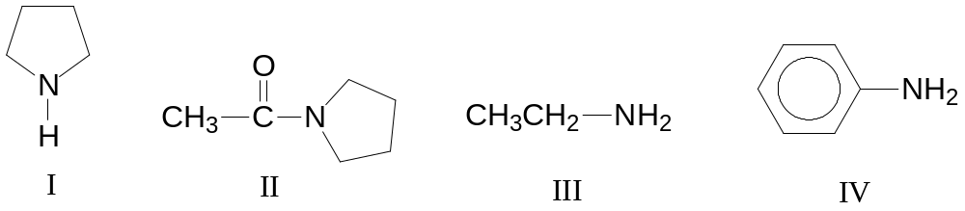

A I, IV, III, II C II, IV, III, I
B I, III, IV, II D II, III, IV, I

23 Which of the following can be used to distinguish between the following two compounds?

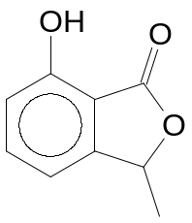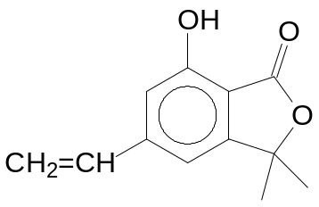

A hot acidified K₂Cr₂O₇
B hot acidified KMnO₄
C neutral FeCl₃(aq)
D Br₂(aq)

24 An organic compound has the following properties:

- It gives a yellow precipitate with alkaline aqueous iodine solution.
- It gives an orange precipitate with 2,4-dinitrophenylhydrazine.
- It forms a brick-red precipitate with Fehling’s solution.

Which compound could give these results?

A CH₃COCH₂C(OH)(CH₃)CH₂CHO
B CH₃COCH=CHCH(CH₃)CO₂H
C CH₃COCH₂COCH₂CH₃
D CH₃COCH₂C₆H₄CHO

25 A chloroalkane W with molecular formula of C₅H₁₁Cl exhibits optical activity. On warming W with alcoholic NaOH, two alkenes X and Y are formed, X being the major product. One of the products of the reaction between X and hot acidified potassium manganate(VII) gives a yellow precipitate with alkaline aqueous iodine. Which of the following could be W?

A CH₃CHClCH₂CH₂CH₃ C CH₃CH(CH₃)CHClCH₃
B CH₃CH₂CHClCH₂CH₃ D CH₃CCl(CH₃)CH₂CH₃

26 Consider the reaction between butanone and hydrogen cyanide in which the enthalpy change of the reaction is near zero. Which one of the following statements is incorrect?

A The reaction is catalysed by a small amount of base.
B The slow step involves the formation of a C−C bond.
C The Gibbs free energy of the reaction is positive at high temperatures.
D The reaction between butanal and hydrogen cyanide is slower than the reaction between butanone and hydrogen cyanide.

27 What is the structure of Q in the following reaction scheme?

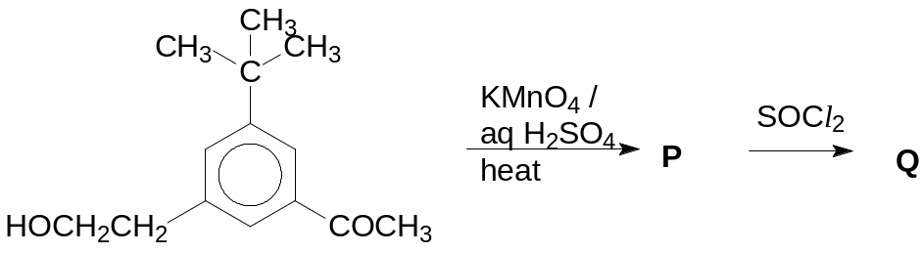
A | 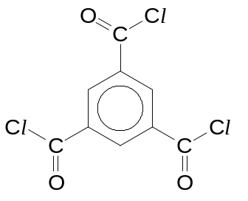 | C | 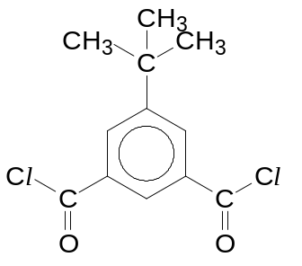
B | 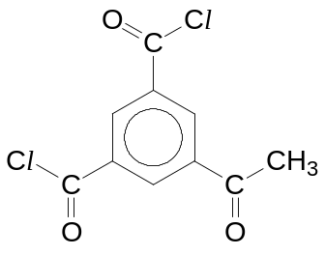 | D | 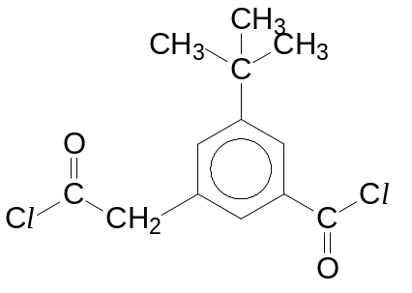
28 A key molecule in the chemistry of vision is the highly conjugated rhodopsin, which is synthesised in the rod cells of the eye from 11-cis-retinal and a primary amine in the protein opsin.

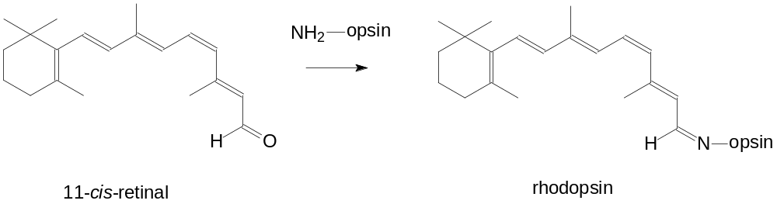
Which of the following statements is correct?

A 1 mole of 11-cis-retinal reacts with 5 moles of hydrogen gas.
B The reaction between 11-cis-retinal and NH₂-opsin is a condensation reaction.
C The reaction of 11-cis-retinal with LiAlH₄ produces a product that is optically active.
D The reaction between 11-cis-retinal with hot acidified potassium manganate(VII) produces a total of five different organic products.

29 Aspartame, a non-nutritive sweetener marketed under the trade name NutraSweet, is the methyl ester of a simple dipeptide, Asp−Phe−OCH₃.

The structures of Asp and Phe are shown as follows:

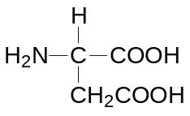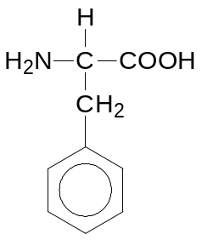
Asp Phe

The isoelectric point of aspartame is 5.9. Which of the following is the predominant species present in an aqueous solution at physiological pH 7.3?

A | 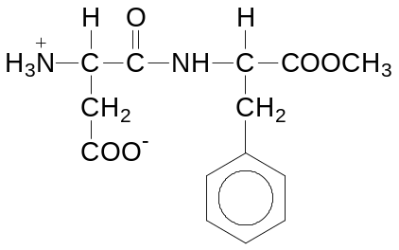
B | 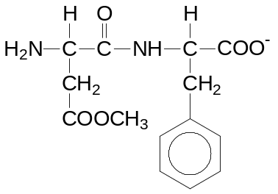
C | 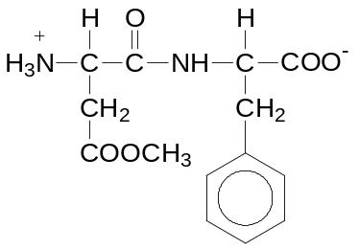
D | 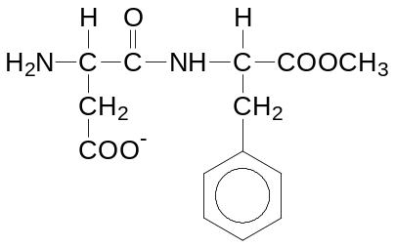

30 The structures of some amino acids are shown below:

glutamic acid | 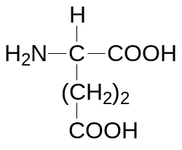
lysine | 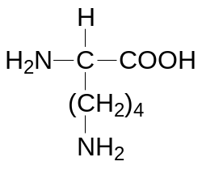
phenylalanine | 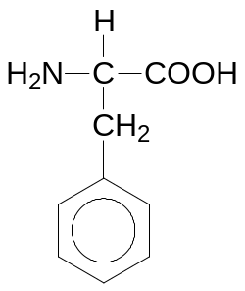
serine | 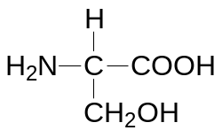
valine | 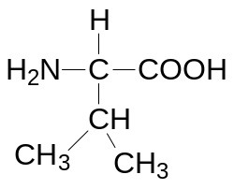

Which of the following pairs of amino acids are likely to be found on the outside of a globular protein, and which on the inside?

on the outside on the inside
A glutamic acid and lysine valine and phenylalanine
B valine and phenylalanine glutamic acid and lysine
C serine and lysine valine and glutamic acid
D glutamic acid and valine phenylalanine and serine
Section B

For each of the questions in this section, one or more of the three numbered statements 1 to 3 may be correct.

Decide whether each of the statements is or is not correct (you may find it helpful to put a tick against the statements that you consider to be correct).

The responses A to D should be selected on the basis of

A | B | C | D
1, 2 and 3  are  correct | 1 and 2  only are  correct | 2 and 3  only are  correct | 1 only  is  correct

No other combination of statements is used as a correct response.

31 For which of the following pairs does the first species have a smaller bond angle?

1 OCl₂, SnCl₂
2 NF₃, NCl₃
3 I₃–, N₃–

32 Given only the standard enthalpy changes of combustion of carbon, hydrogen and methane, which of the following can be calculated?

1 The enthalpy change for the hypothetical reaction:
2CO₂(g) + 4H₂O(l) → 2CH₄(g) + 4O₂(g).
2 The enthalpy change of formation of water.
3 The enthalpy change of formation of liquid methane.

33 A 20 cm³ solution contains 1 x 10^{–3} mol dm^{–3} X⁺ and 1 x 10^{–3} mol dm^{–3} Y²⁺ metal ions. 7 x 10^{–4} mol of solid sodium sulfate is added to the solution. The numerical values of the solubility product of X and Y sulfates are 7.4 x 10^{–7} and 9.1 x 10^{–6} respectively. What can be deduced from this information?

1 The metal Y sulfate will precipitate out selectively.
2 There are more X⁺ ions than Y²⁺ ions remaining in the solution.
3 The solubility products of metal X and Y sulfates will change when 2 g of solid sodium sulfate is added to the solution.

34 A sample of copper which contains silver and zinc impurities can be purified by electrolysis. Which of the following statements are true?

1 The impure copper is made the anode.
2 Both zinc and silver are preferentially oxidised to its ions.
3 The concentration of the copper(II) ions in the electrolyte remains constant.

The responses A to D should be selected on the basis of

A | B | C | D
1, 2 and 3  are  correct | 1 and 2  only are  correct | 2 and 3  only are  correct | 1 only  is  correct

No other combination of statements is used as a correct response.

35 Astatine is an element in Group VII. Which of the following statements are correct?

1 Silver astatide is insoluble in aqueous ammonia.
2 Sodium astatide and hot concentrated sulfuric acid react to form astatine.
3 Hydrogen astatide is less stable to heat than hydrogen iodide.

36 A stability constant is an equilibrium constant for the formation of a complex in solution.

Consider the formation of [Ni(NH₃)₆]²⁺(aq) in solution:

[Ni(H₂O)₆]²⁺(aq) + 6NH₃(aq) [Ni(NH₃)₆]²⁺(aq) + 6H₂O(l)

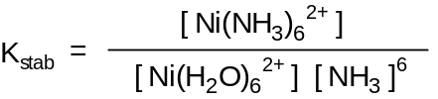
The equilibrium constant, K_{stab}, of the above reaction, taking the concentration of water as being constant, is
K_{stab}

The following table lists some iron complexes together with their colours and the values of their stability constants.

complex | colour | K_{stab}
[Fe(SCN)(H₂O)₅]²⁺(aq) | deep red | 1 x 10²
[FeF₆]³⁻(aq) | colourless | 2 x 10¹⁵
[Fe(CN)₆]³⁻(aq) | orange-yellow | 1 x 10³¹
[Fe(edta)]²⁻(aq) | colourless | 2 x 10¹⁴
[Fe(edta)]⁻(aq) | yellow | 1 x 10²⁵
[edta = (⁻O₂CCH₂)₂NCH₂CH₂N(CH₂CO₂⁻)₂]

Which of the following statements are incorrect?

1 Addition of KSCN(aq) to a solution of Fe³⁺(aq) produces a deep red solution which remains red when KF(aq) is added.
2 Addition of edta to a solution containing [FeF₆]³⁻(aq) does not produce any colour change.
3 Addition of KCN(aq) to a solution containing [Fe(SCN)(H₂O)₅]²⁺(aq) produces an orange-yellow solution.

The responses A to D should be selected on the basis of

A | B | C | D
1, 2 and 3  are  correct | 1 and 2  only are  correct | 2 and 3  only are  correct | 1 only  is  correct

No other combination of statements is used as a correct response.

37 The pK_{a} values of the following compounds are given below.

Compound | pK_{a}
H₂CO₃ | 6.4
CF₃COOH | 0.2
CH₃CH₂OH | 16.0
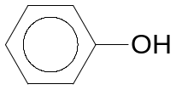 | 10.0
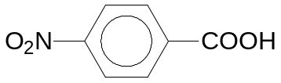 | 3.4
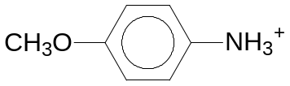 | 5.3

In which of the following acid-base reactions will the equilibrium favour the products over the reactants?

1 | 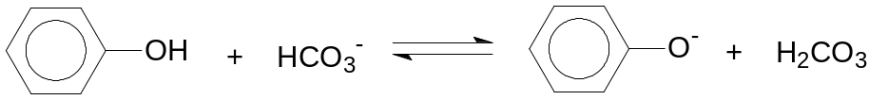
2 | 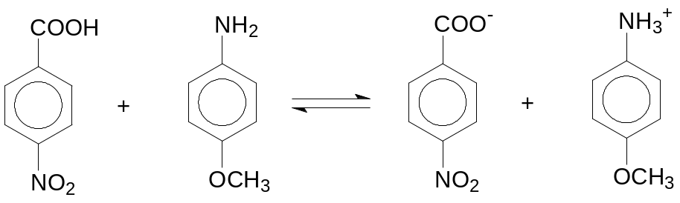
3 | 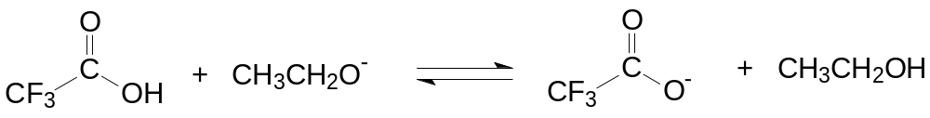

The responses A to D should be selected on the basis of

A | B | C | D
1, 2 and 3  are  correct | 1 and 2  only are  correct | 2 and 3  only are  correct | 1 only  is  correct

No other combination of statements is used as a correct response.

38 Which products are formed when phenyl propanoate undergoes acidic hydrolysis in the presence of water labeled with the ¹⁸O isotope?

1 CH₃ CH₂CO¹⁸OH
2 C₆H₅¹⁸OH
3 C₆H₅CO¹⁸OH

39 The structures and pK_{a} values of fumaric acid and maleic acid are given below:

 | pK_{a1} | pK_{a2}
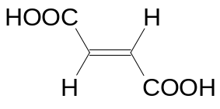  fumaric acid | 3.0 | 4.5
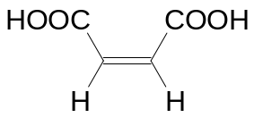  maleic acid | 1.9 | ?

Which of the following statements are correct?

1 Maleic acid has a lower boiling point than fumaric acid as it can form intra-molecular hydrogen bonding.
2 pK_{a2} of maleic acid is larger than that of fumaric acid because the acidic hydrogen atom in maleic acid can be stabilised by intra-molecular hydrogen bonding, hence making it more difficult to remove.
3 For each acid, pK_{a2} is larger than pK_{a1} because it is easier to remove a second proton from the conjugate base formed in the first ionisation.

The responses A to D should be selected on the basis of

A | B | C | D
1, 2 and 3  are  correct | 1 and 2  only are  correct | 2 and 3  only are  correct | 1 only  is  correct

No other combination of statements is used as a correct response.

40 Consider the following reaction scheme.
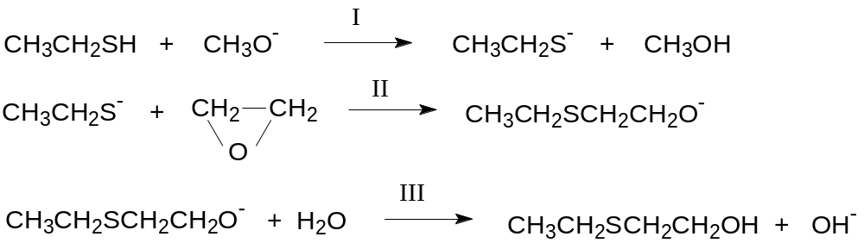

Which of the following types of reactions are shown in reactions I, II and III?

1 oxidation
2 nucleophilic substitution
3 neutralisation

END OF PAPER

